The Meadows School

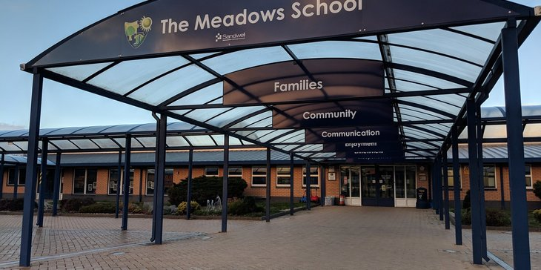
Safeguarding Information
2023 - 2024

FLOW CHART FOR RAISING SAFEGUARDING CONCERNS ABOUT A CHILD at The Meadows School
Designated Safeguarding Lead and Deputy Designated Safeguarding Leads:
DSL: Theodora Papaspyrou
DDSLs:
- Graham Spencer
- Kevin Hurcombe
- Fay Bedford
- Rebecca Malpass
- Kerry Patrick

Safeguarding Link Governor:
Phillip Butcher

The local authority Designated Officer for concerns about adults is:
LADO
Contact details:
0121 569 4770
Sandwell
Lado@sandwelllchildrenstrust.org

Speak to a DSL

Designated Safeguarding Lead discusses decision with DDSLs and agrees to refer to social care
Decision made to discuss the concern with the parents/carers
Designated Safeguarding Lead keeps concern form in secure, confidential safeguarding file.
Contact Details
Social Care Referrals:

0121 569 3100 Sandwell MASH
Prevent/Channel Referrals:
SPOC
Theodora Papaspyrou
Decision made to refer the concern to social care
or
Agency plus LTSs:
Fill in Concern Form (Staffroom)
Designated Safeguarding Lead reviews concern form and makes a decision about next steps
Decision made to monitor the concern.
Monitor
Refer
Concern recorded on CPOMS
NSPCC Whistleblowing Helpline 0800 028 0285
In exceptional circumstances, anyone may report concerns directly to children’s social care.
Monitor
Refer
Once discussed with parents, Designated Safeguarding Lead decides to discuss further with parents, monitor or refer to social care
Discuss
Record
Class teacher asked to monitor child and feedback to the Designated Safeguarding Lead within an agreed timescale
Safeguarding Statement
We are committed to safeguarding and promoting the welfare of children. We expect all staff, volunteers and visitors to share this common commitment.
Our priority is to ensure our school remains a safe place for children, staff and all other members of our school community. This leaflet contains information about our expectations of you whilst visiting the school. If you are unclear about anything in it, please speak to any of the contacts named within. Please keep the leaflet in a safe place so that you can read it again if you need to.
Staff working with children maintain an attitude of ‘it could happen here’ where safeguarding is concerned. When concerned about the welfare of a child, staff should always act in the best interests of the child.

Governors
Governors at The Meadows School are aware of their role in safeguarding children and review the Safeguarding and Child Protection Policy annually.

Phillip Butcher is the Designated Safeguarding Link Governor who liaises with the school to review school policies, procedures and reports.

Visitor procedures
Visitors to the school should sign in at the reception where you will be given a visitor’s badge which you should wear while in school. Please remember to sign out when leaving the premises, even if you are due to return on the same day.
We ensure that all adults who work or volunteer in our school are subject to the appropriate security and appointment checks including Disclosure and Barring System (DBS) checks.
If a visitor does not have the relevant ID/Checks, they must wait until a suitable member of staff is available to supervise access.
If you have any concerns or queries about any of the guidance below, please seek advice from a Senior Leader immediately.

What Do I Do If I am Worried About a Child?
If you become concerned about:
- Something a child says
- Marks or bruising on a child
- Changes in a child's behaviour or demeanour

Please report these concerns to one of the School’s Designated Safeguarding Lead using a note of concern form - these can be found in the staff room or at reception.
Child abuse happens to all children regardless of gender, culture, religion, social background and those with or without a disability. You can find further information in our Safeguarding and Child protection policy, online or by requesting a copy.

Designated Safeguarding Lead and Deputy Designated Safeguarding Leads at The Meadows:
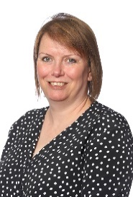
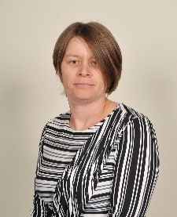
Graham Spencer
Deputy DSL

Kerry Patrick
Deputy DSL

Rebecca Malpass
Deputy DSL

Fay Bedford
Deputy DSL

Kevin Hurcombe
Deputy DSL
Theodora Papaspyrou
DSL

The role of the DSL is to keep child protection information and records securely, offer advice and support to colleagues, pass on concerns to the relevant authorities and liaise with social workers.
The Safeguarding Team can be contacted through the school Office on 0121 569 7080
What Do I Do If a Child Discloses They Are Being Harmed?
Whilst this can be an alarming situation, it is important that you know what to do in such an eventuality and for you to stay calm and controlled.

- Listen carefully to the child, particularly what is said spontaneously.
- Remember not to show shock or disbelief.
- Do not promise confidentiality. Reassure the child but do not make promises that might not be possible to keep.
- Do not interrogate or ask leading questions.
- Reassure the child that is not their fault; stress that it was right to tell.
- Record carefully what the child says in their own words including how and when the account was given. Date, time and sign the school’s Concern Form (accessible in the staff room). Pass this on to a Designated Member of Staff for Safeguarding immediately.

A copy of the school’s Safeguarding policy can be accessed in the school staff room and can also be viewed on the school website. You can also ask for a copy from reception.

Types of harm
We all have a responsibility to keep children safe, both at home and in school. Harm is identified in four ways:

Physical - when a child is deliberately hurt or injured.
Sexual - when a child is influenced or forced to take part in a sexual activity. This can be a physical activity of no-physical, e.g. being made to look at an inappropriate image.
Emotional - when a child is made to feel frightened, worthless or unloved. It can be by shouting, using threats or making fun of someone. It can also be when children see their parents, or visitors to the home, fighting or using violence.
Neglect - when a child is not being taken care of by their parents/guardians. It can be poor hygiene, poor diet, not keeping appointments for additional support, not coming to school or being left home alone.

Allegations against a member of staff

Any concerns about a member of staff (including supply staff, volunteers and contractors) should be reported to the Head Teacher. In the continued absence of our substantive Head Teacher, please report any concerns about a member of staff to James Horspool - Head Teacher (james.horspool@themeadows.sandwell.sch.uk)

Low level concerns about all adults including supply teachers, volunteers and contractors should be reported to the Head Teacher.

If the concern is about the Head Teacher, it should be reported to the Chair of Governors. Please report any concerns to the Chair of Governors – Phillip Butcher – phillip.butcher@themeadows.sandwell.sch.uk

Staff Conduct
Staff are required to work in a professional way with children. Our Code of Conduct makes all staff aware of the procedures and protocols that must be adhered to (You may access our Staff Code of Conduct policy on our website and/or receive a paper copy upon request).
All Staff and Visitors are expected to:

- Treat everyone with respect
- Act as a positive role model at all times, displaying high standards in the use of language, manner, punctuality and preparation.
- Dress appropriately ensuring their clothing is not likely to be viewed as offensive or revealing.
- Ensure they are visible by a member of staff if they are with children.
- Never share personal information with a student. If a student tries to share these details with visitors or staff, inform the class teacher as soon as possible.
- Do not leave equipment unattended.
- Familiarise themselves with the personal profiles and needs of students they are supporting and working with.
- Keep information confidential.

Student Behaviour
During your visit you might observe a student struggling to manage their behaviour. We would like to reassure you that staff have been trained to manage these situations keeping the children, themselves, and others safe.

If you would like to report a behaviour incident, you may use our behaviour recording form (accessible in the staffroom) and pass it on to the class team to be recorded on SLEUTH (online behaviour recording and monitoring system).

Our behaviour policy can be read online, or you can request a copy from a member of staff.

Sexually Harmful Behaviours (SHB)
Concerns of child-on-child sexual violence and sexual harassment, including those that have happened outside of the school or college premises, and or online must be reported to the DSL.

Online Safety
Our school online safety policy is available to read on the website or you can request a copy from a member of the admin team.

Mobile Phones

Staff, visitors and volunteers in school should keep their mobiles switched off and may only use these within the confines of the staffroom or a school office when no children are present. Personal Cameras and mobile phones should not be used to take pictures of children.

Smoking
Meadows is a non-smoking site; this includes e-cigarettes and vapes. With this in mind you are not permitted to smoke in any of the school’s offices, or any other building or grounds owned or occupied by the school at any time. Smoking whilst on the school’s premises may be subject to disciplinary action.

Fire Safety

Upon discovering a fire, you should raise the alarm immediately. In the event of a fire, the alarm will sound (loud, continuous signal). On hearing this, please make your way to the nearest identified fire exit. Fire Safety procedures and plans are displayed throughout the building, giving clear instructions on the locations of emergency exits and fire assembly points. Do not return to the building again unless you are told to do so by a fire marshal or the fire coordinator. The names of the fire marshals on site are displayed throughout the building. If you think that you will need help during an emergency evacuation of the building, please let the staff at reception know on arrival.

Accidents, Incidents & Near Misses

Any accidents, incidents or near-misses which occur on site must be reported at reception.
An Accident, Incident & Near Miss form may be accessed at the Admin office.
First Aid
All accidents regardless of severity need to be reported at reception. If First Aid is required, reception staff will request assistance. The name and photographs of trained first aiders on site are displayed at the front reception desk but also by first aid boxes across the school.
A defibrillator is onsite, located in the main reception.
Partial or Full Lockdown
In the event of a partial or full lockdown, follow the internal communication systems and the instructions of school staff.

Housekeeping
If you notice any damaged or faulty equipment, please inform a member of SLT immediately or alternatively inform our Site Supervisors. Our Site Supervisors are Trevor Lloyd (trevor.lloyd@themeadows.sandwell.sch.uk) and Craig Carter
(craig.carter@themeadows.sandwell.sch.uk). You may submit a ticket on the Site Team Helpdesk (https://themeadows.freshdesk.com/support/tickets/new).

Hot drinks are only permitted in the staff room and offices.
Please remember that Meadows school is a NUT FREE ZONE!
Meadows School Vision
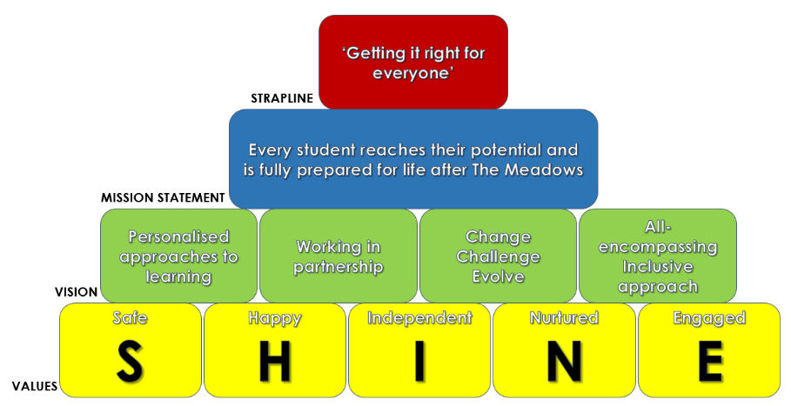

We hold our students at the centre of everything we do and work to enable them to feel ‘Safe’ in their school environment, to feel ‘Happy’ in themselves and in the work that they do, to be as ‘Independent’ as possible in and out of school, to feel ‘Nurtured’ by those around them and to feel ‘Engaged’ in their activity.

Our vision is to achieve this through personalised approaches to learning, whereby we recognise each of our students as unique individuals with specific needs and tailor our approaches to promote their development. We work in partnership with other schools, agencies and the wider community to develop our links and provide the optimum provision for our students. We constantly seek to change, challenge and evolve as a school and recognise the need to constantly strive to better ourselves. All of this is done through an all-encompassing inclusive approach, involving all of our stakeholders to ensure everyone upholds these same visions and values.

We prioritise the mental health and wellbeing of all our stakeholders including staff, students and families. We strive to ensure that everyone feels supported and valued and that their emotional wellbeing is accounted for. Both students and staff have access to a number of initiatives in order to do this and we work collaboratively with external agencies in order to provide a safe and supportive environment for everyone.

All of this feeds into our mission statement which is that ‘Every student reaches their potential and is fully prepared for life after The Meadows’. We hope that working towards our visions and based on our core values will enable us to achieve this and will ultimately mean we are ‘Getting it right for everyone’ – students, staff and families.

Thank you for helping us at Meadows School to safeguard the students in our care by adhering to the guidelines set out in this leaflet.

Senior Leadership Team

Kevin Hurcombe
Assistant Headteacher
Graham Spencer
Assistant Headteacher
James Horspool
Head Teacher
Theodora Papaspyrou
Deputy Head Teacher

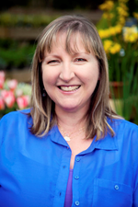

Aleatheia Benjamin
Business Manager
Eileen Pace
Assistant Headteacher
Sam Forbes
Assistant Headteacher

The Meadows School
Dudley Road East
Oldbury
West Midlands
B69 3BU
0121 569 7080

